Thoughts on the

Coats of the Fur Trade

By Gene Hickman

Coats
Any of the following types of “coats” would be a great addition on those cool evenings or early mornings. You or your party will have annual trapping trips & primitive camping/hunting trips that definitely require some warmer garments. If it snows in June, this will also be a huge asset! But coats or capotes are not necessary. You can always wear a blanket as a matchcoat (period correct blanket of course) or buffalo robe when necessity dictates. When we use the term coat here we mean as Chronister and Landry (1995) relate that …a garment worn over the shirt (or shirts) as a primary outer garment They go on to relate that …The journals of John Bradbury (1811), Harrison Rodgers (1826), James Ohio Pattie (1827), William Drummond Stewart (in Edward Warren), and Philip Edwards (1834) all descrive the authors or trappers wearing leather or deerskin or “fringed” hunting shirts. Larpentuer described his own “cowskin coat” and “buckskin shirt” worn over two favric shirts in 1833 (Larpentuer, 1898).

There are a variety of coats that are worn, & as stated in the general article on clothing what you wear is dependent on your ethnic & geographic background as well as your occupation or “station” in life. The variety of clothing is illustrated in the reference given by Josiah Gregg (1926) as he is starting out with a caravan from Independence, Missouri to Santa Fe in 1831, …The wild and motley aspect of the caravan can be but imperfectly conceived without an idea of the costumes of its various members. The most fashionable prairie dress is the fustian frock of the city-bred merchant furnished with a multitude of pockets capable of accommodating a variety of extra tackling. Then there is the backwoodsman with his linsey or leather hunting-shirt—the farmer with his blue jean coat—the wagoner with his flannel-sleeve vest—besides an assortment of other costumes which go to fill up the picture.

What you wear will also depend on how much money you have, whether you are newly arrived from the settlements, you are working out of a trade fort, you are coming from rendezvous, you are traveling with a well supplied brigade or you are a free trapper “on-your-own-hook.” This may mean the difference of how much cloth vs. leather that you wear.

Don’t think that the coats in the Rocky Mountains are either trapper made leather coats or capotes made from blankets. If you research the records you’ll find that there is a lot of diversity not only in styles but materials in the time period from 1800-1840. Rex Allen Norman (1996) tells us that …Coats are made of cloth or heavy flannel or light blanketing are seen, mostly in blue.

Frock Coats

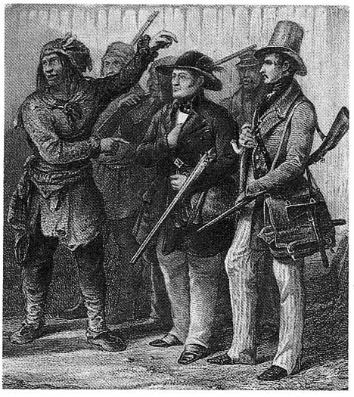

Frock coats were the suit coat or sport coat of the day. Bodmer’s painting (1833-34) of he & Prince Maxmillian at Fort Clark. The painting shows both Bodmer & Maxmillian wearing frock coats. Whereas their interpreter, Trousant Charbonneau, is wearing a leather garment. You can see that these frock coats were tailored & came to just above the knee. Many of the coats whether they be made of leather or the even the hooded capotes, follow the same basic 19th century tailoring with “key-hole” backs, and articulated sleeves. The average coats of all styles are mid-thigh in length and rarely below the knee.

Frock coats are shown by several artists, Miller included. The traders, booshways, clerks, partners, etc. would more commonly have had a frock coat, as it would give some distinction to their dress. As Charles Hanson (1990) has said …fur trading society was a structured society and there were always well-defined social distinctions. So like the rest of society at the time there was a real class distinction & what the various “classes” wore was often distinctive too. As Charles Hanson goes on to say The trader had a reputation to preserve. He had to have the respect of his employees and his customers…He made no attempt to resemble or emulate the Indians or the trappers or voyageurs who worked for him. Instead he wished to appear as a leader and a supplier of things. Charles Mackenzie of the North West Company, 1806, men of dignity must deck themselves better than the common voyageur if they wish to be considered as they should be. The “lower” classes may often have worn the same style of garment but of less expensive materials.

Around 1812 the Frock coat develops from what were formerly 18th century tail coats. At first it is a cold weather piece of clothing which later evolves into a coat for everyday wear. In the 1820's you’ll see the frock coat being worn as both an overcoat & for everyday wear. Ten years later the frock coat replaces the tailcoat for everyday wear & the tailcoat becomes more or less a dress item for the middle class. The frock coat has many different types of collars styles, cuffs, & pocket locations. In the 1820's thru the 1830's, the coat had a flair to the skirt that was lost by the 1850's (Custom Vestments, http://www.customvestments.com). Custom Vestments will also sell you a custom pattern for a frock coat or an historically finished correct frock coats, with several options available.

Many of the leather coats we see in sketches & paintings from the period seem to be copied from a basic frock coat pattern. There are also some styles of shorter caped & un-caped coats, which have also been called canoe coats, & later the uncapped style of wool mackinaw. Dark colored wool of blue, black, gray, brown or green are most appropriate, but rose, red, or even braintan leather would be correct too. We would rank the frock style coats as one of the more difficult items for you to make yourself. This is due mainly to the “key-hole two-piece back” or multi-body styles, the articulated sleeves & the “skirted” or pleated bottoms. Luckily, a number of the traders & sutlers carry ready-made coats & any number of local tailors or seamstresses, specializing in historic clothing, will contract to sew one up for you. Two of the best would by; Barry & Judy McPherson at baggage@mts.net, & Custom Vestments at http://www.customvestments.com).

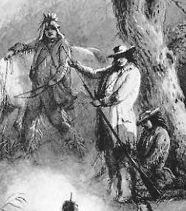
Here is a portion of a Miller’s sketch, Roasting the Hump rib, showing three hunters camped & roasting a side of hump ribs (Ross, M.C. 1951). Notice that the hunter, Burrows, in the middle, wears a frock coat, while LaJeunesse, standing by his horse, wears a leather coat, cut much like the frock coat. Francois leans against the tree wearing another leather coat.

At the larger Hudson’s Bay company posts, good durable & roomy shirts, trousers & capotes were sold to the working employees…Traders and other officers often ordered their clothing from English or Scottish tailors – frock coats, waist coats, trousers and cravats. In both the western United States and Canada, the largest trading post had tailors who made “chief’s coats’ for the Indians and items of clothing for company employees (Michael, 1989).

Here are a few invoice & journal entries for some coats & cloaks:

1 Blue Coat Left in Trunk in Care of Mr. Wm. L. Sublette April 12th 1832. (http://www.xmission.com/~drudy/mtman/bizrecs.html).

4 Embroidered Cloaks $2.25[ea]. Invoice of Sundry Merchandise sold & delivered to the Missouri Company by Fr^{s} Regnier at St. Louis the 3^{d} May, 1809 (Missouri Company 1809).

3 bottle green frock coats
3 olive green frock coats
Invoice of merchandise shipped on board S.B. Diana, C.M. Halstead Master bound for the upper Missouri River & consigned for account & risk of upper Missouri outfit 1835 under mark in the margin (Diana Invoice, 1835).

1 Black cloth Dress coat from his list, Robert Newell's 1836 Notebook.

The 1831 Fort Union inventory listed four blue frock coats, and in the 1834 the “Fort had eight “French” coats in stock in green, blue, brown and drab and 28 “roundabouts” (short jackets) in blue cloth and cordoury (National Park Service, 1995).

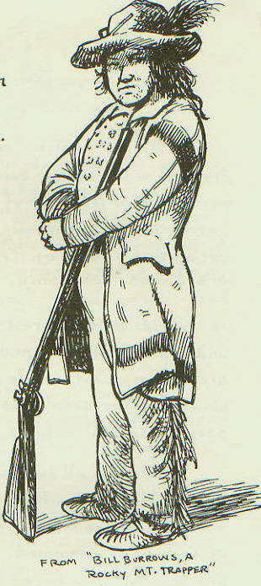
Here is an excellent sketch by Rex Allen Norman showing “Bill Burrows, A Rocky Mountain Trapper” depicted in one of A.J. Miller’s 1837 field sketch (Norman, 1996). This looks like a traditional frock coat. It is more fitted & it does however appear to be made from a blanket, with the blanket style colored bands on it. It also seems to be well made as it has a pocket, collar, no hood, & fitted (articulated) sleeves.

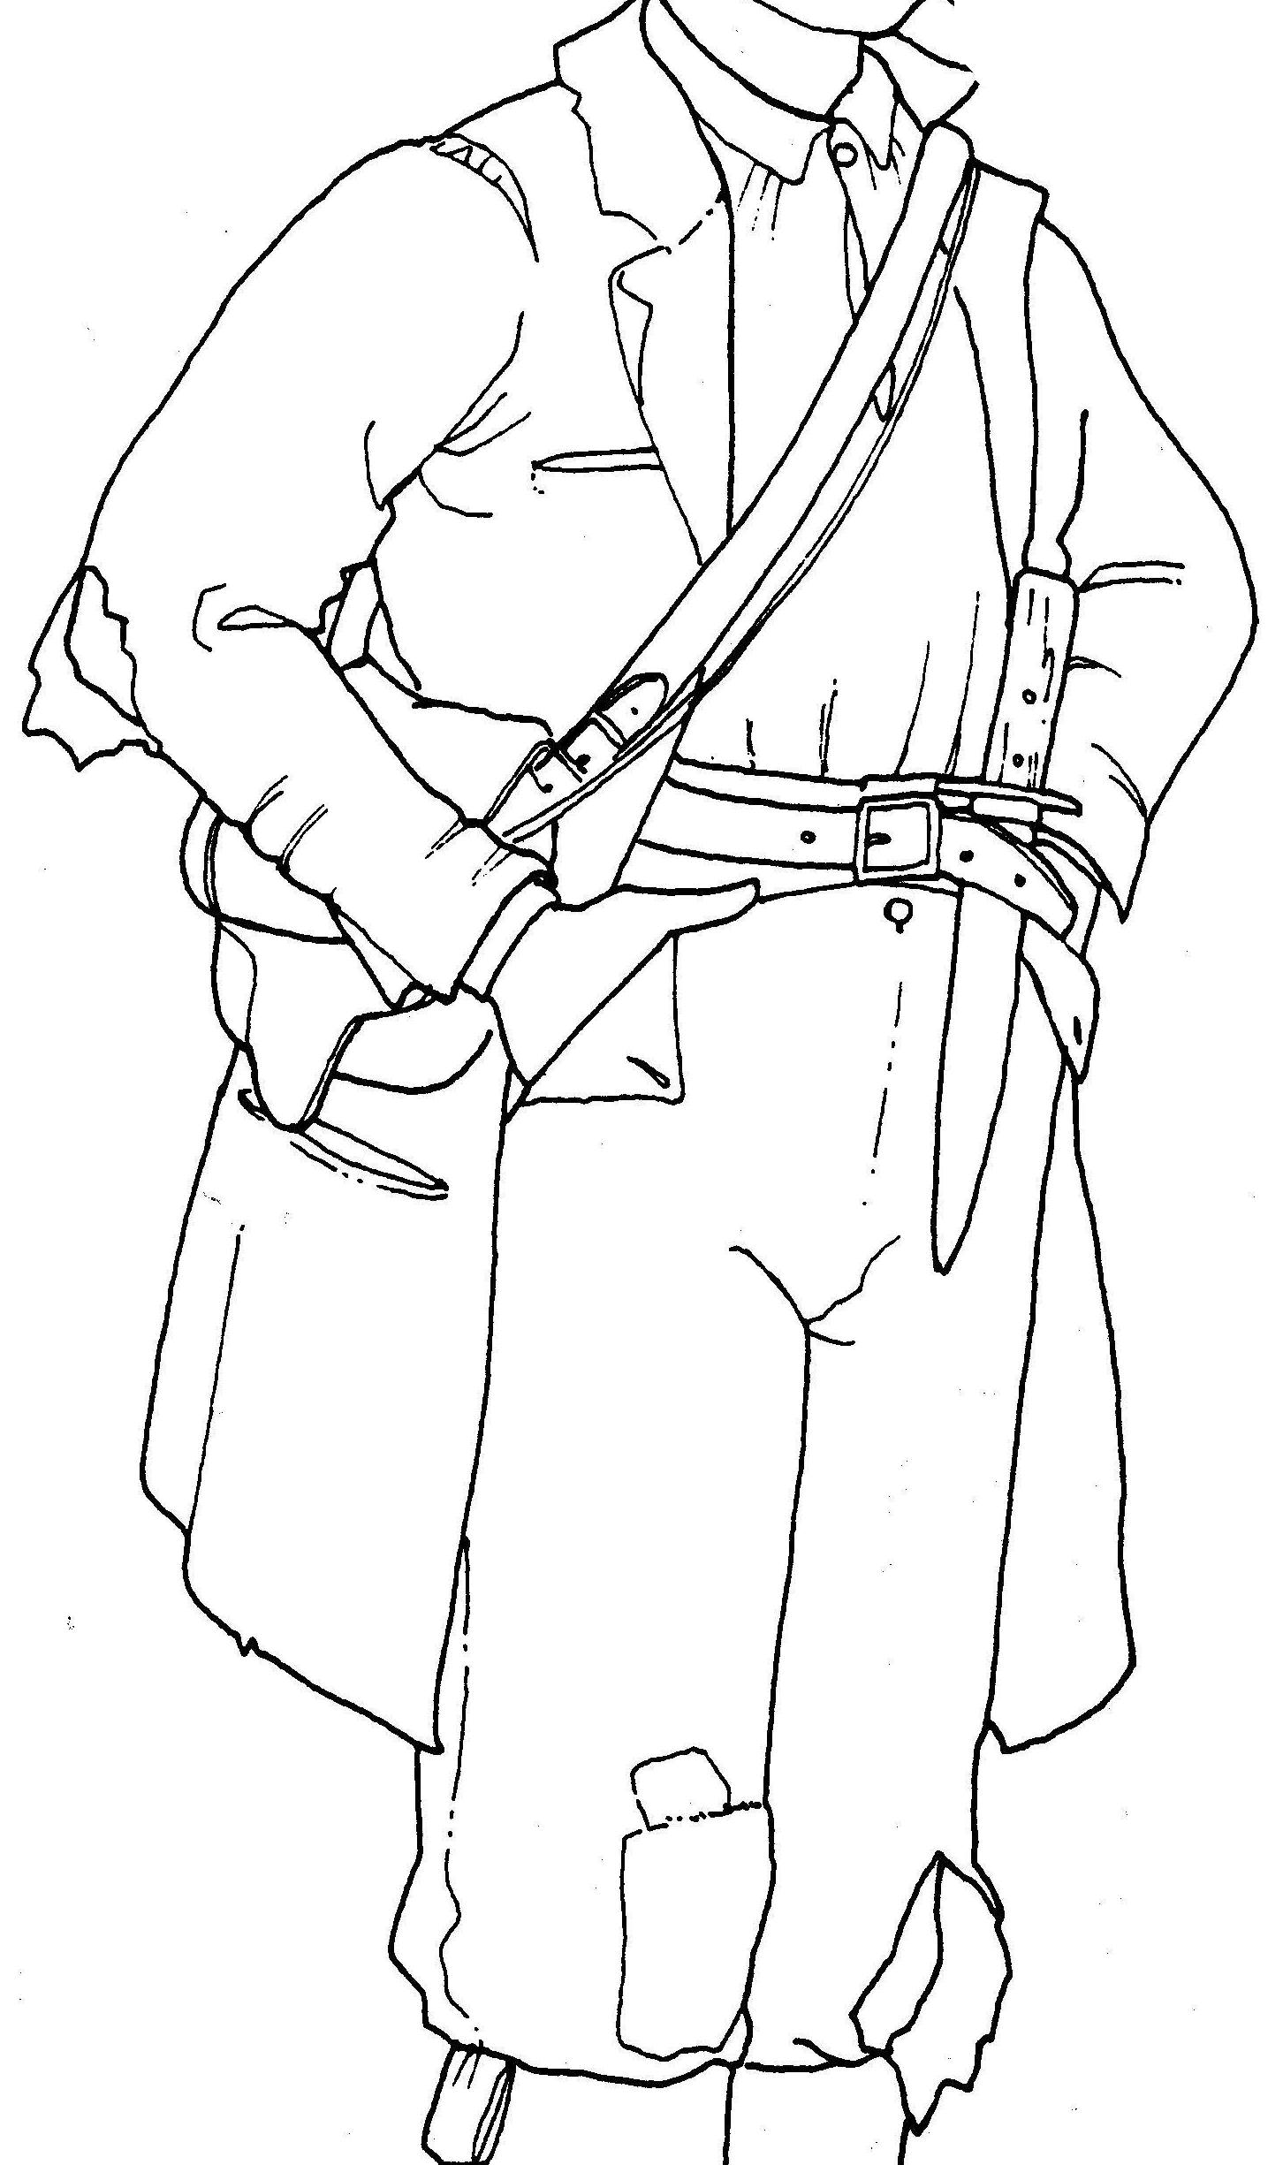
D.W. Rickman, 1988.
Sutter’s Fort Costume Manuel.

Wear & tear on the trail often took a heavy toll on these cloth coats. So unless they were replaced at a Fort or Rendezvous these coats were eventually replaced by leather, usually in the same styles as the previous coats. From the 1700s into the early 1800s a similar coat may have had one or more capes like military surtouts, & some civilian overcoats of the time. These capes added warmth & helped shed water & snow; these were not frock coats as frock coats did not have capes. Hunting frocks should also not be confused with frock coats.

Short Coats or Jackets

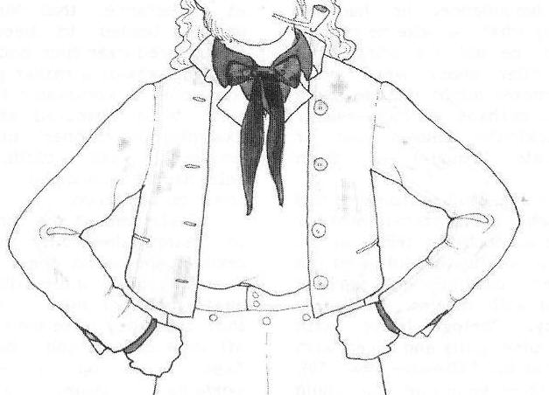
From D.W. Rickman, 1988.
Sutter’s Fort Costume Manuel.

Short coats, jackets, roundabouts, stable jackets, monkey jackets or coatees were all common short jackets with sailors, working men, Mexicans & the military. These garments usually reach to the waist & were made from a variety of materials ranging from light to heavy wool, or duffels. They came unlined, or lined with wool gabardine, cotton, linen, or hemp. Lighter weight and/or fatigue type coatees were also made of hemp, linen, ticking, solid colored cotton, canvas & Russia or Flanders sheeting. They could be double breasted or with a single row of buttons, & with or without collars or lapels.

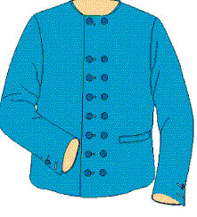

One type of short jacket has a double breast & no collar; although some have collars & others may have a single row of buttons. They also may be with or without pockets. A good historically correct jacket, with variations, can be made from the Kannik’s Korner pattern KK-4551 (Man’s Double Breasted Short Jacket). These blue illustrations came from the Kannik’s Korner pattern.

By the end of the 19th century the roundabout or a monkey jacket (like the jackets worn by an organ grinder's monkey), was a short jacket with collars or lapels. The collar could be standing, ending just above the ear lobe, or the later style, which would have been the horse collar. The collar was shaped like a horse collar, and padded and stiffened. There were many different styles of cuffs. The pockets for this period would have just been welted ones (Custom Vestments, http://www.customvestments.com). The military adopted this style of “short jackect” as a fatigue jacket in 1803 or 1804. This style of jacket was very common with seaman.

You can find a number of entries for “monkey Jackets” in the Fort Hall records. Here are two examples for 1835 as related by Clay Landry (1999
Joseph Gray, February 18, 1835 Monkey Jacket [$]14.
“Pig (Kanaka)”, November 2, 1835, 1 Monkey, Jacket [$]12.

Another short jacket, the coatee developed from the tail coats of the 19th century & were essentially tail coats with very short tails. However, the early military coatee had little or no tail. Here’s a quote concerning Abraham Lincoln wearing a short tailed coat or coatee, when he first ran for office in 1832: "The election being near at hand only a few days remained for his canvass. He wore a mixed jean coat claw hammer style and bobtail -- in fact it was so short in the tail he could not sit on it; flax and tow - linen pantaloons, and a straw hat. I think he wore a vest, but do not remember how it looked." (A letter from Herndon to A.Y. Ellis dated June 5, 1866)

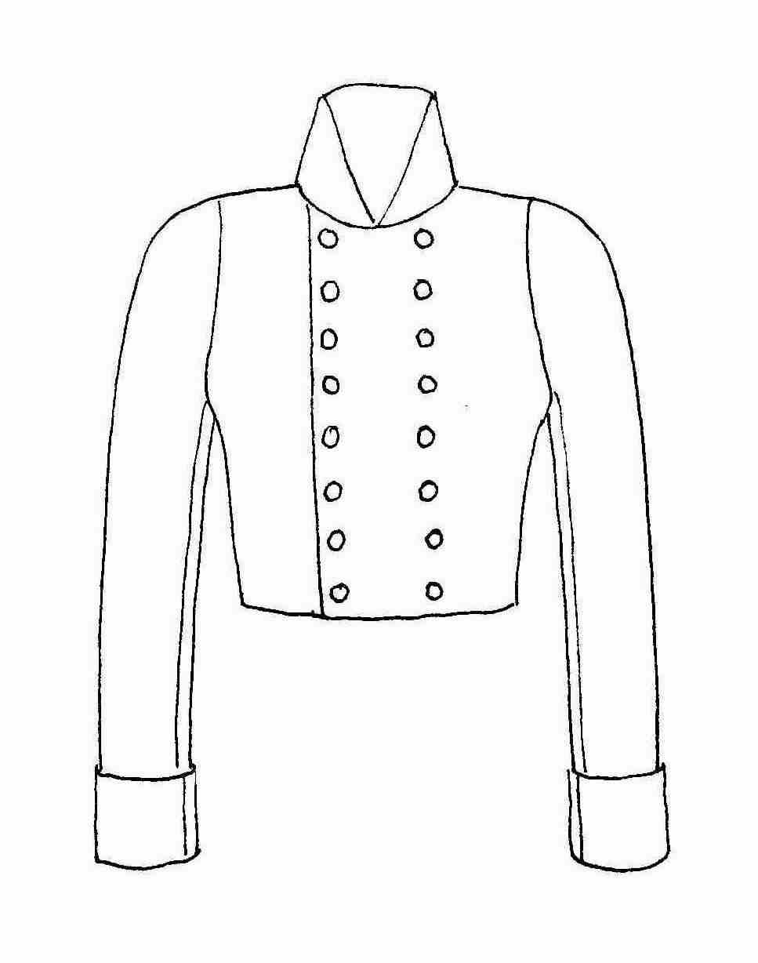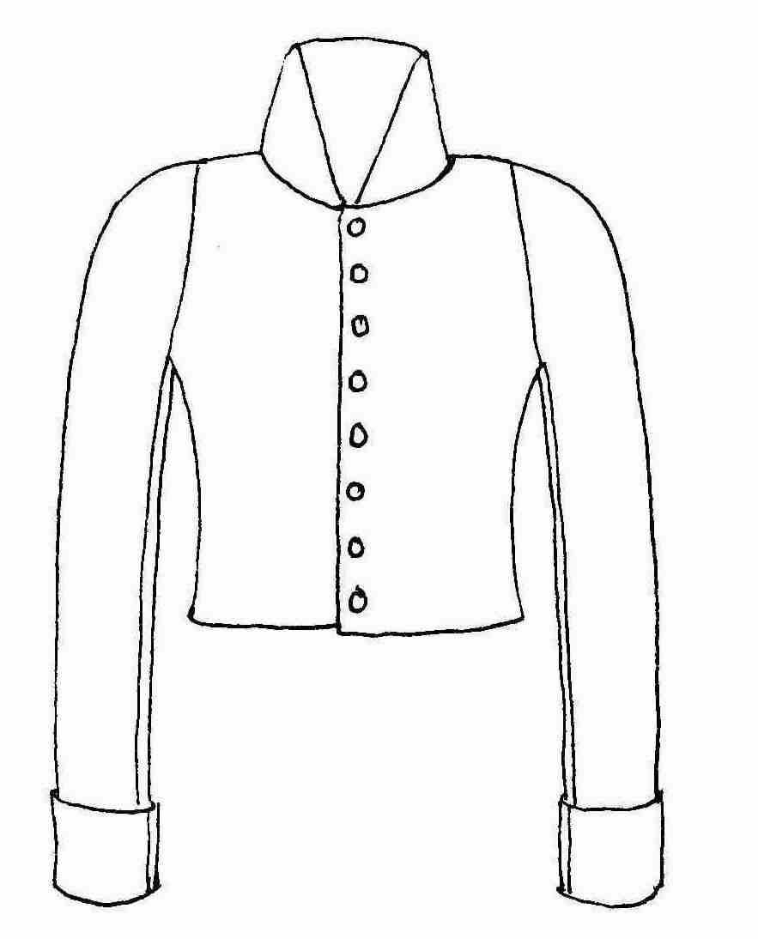

Military style coatees & roundabouts with the high military collars. On the left is the double breasted coatee usually of wool & later some military coatees had short tails. The one with the single row of buttons is the fatigue roundabout usually made of linen or hemp. These styles continue on in the military right up through the Civil War, where they are also known as shell jackets.

Another good looking short jacket & pattern comes from Rocking Horse Farm patterns (Illustration at the right). It is called a workman's jacket or stable jacket & is their pattern RH205. It can be made with or without a collar. Custom patterns or period correct coatees & roundabouts can also be purchased from Custom Vestments at http://www.customvestments.com/.

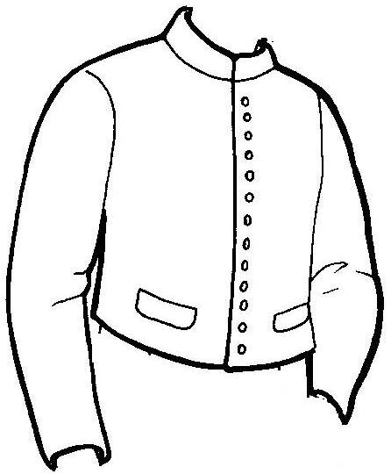

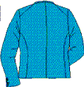
Here’s what the back of these short jackets look like, with characteristic cut some call the “key-hole or two-piece” design, which is a two piece back narrowing at the high waist. Some coats have a one piece back but of the same shape. Yokes seen in modern coats are not common until the late 1800s. Kannik’s Korner back of short jacket illustration.

McPherson (2006) has said that …The short jacket seems to me to have been universal for at least a century. John Lambert has left us a clear image from the 1808 period, which is virtually identical to "Illustration tirée du sketchbook de lady Aylmer",1831.…There are many paintings in our period showing these short jackets. If you look at the Canadian artists don’t just look at voyageurs or fur trade paintings, but also look at just plain old habitants. After all they were all using the same sources for their clothing. You can find jackets in Lamberts, Davies, & Peacheys work, all pre-1821. After 1821 there are a lot of other artists in the 30s & 40s like Bainbrdige, Burrows, Rindisbacher, & Chaplin etc. They all show jackets as well & not too much has changed on those jackets.

As Karl Koster (2006) says …jackets are a great alternative to the capote and I think under-used in this hobby. Koster also recommends the Kannick’s Korner patterns as being well documented & a good pattern to try making a short jacket. Koster has also generated a list of potential fabrics for your “jacket” project.

Barry McPherson (2006) also us that …For all intents and purposes, these jackets were tail coats without tails, and any decent tailcoat pattern with the tails removed, will generate a short jacket of the period. Just don't tailor it too finely! No cuffs are necessary. No M-notch collar is desirable, and two simple welt pockets as in a vest (waistcoat) will suffice. Wool in any of its imported fur trade variations, as well as étoffe du pays will work… Grey would seem to be the preferred color, and one supposes that this in part, explains the tendency to call NWers "the Grey Coats".

There is also another short jacket, called a chaqueta commonly worn by New Mexican men. It is a …jacket of cloth gaudily embroidered with braid and fancy barrel buttons (Gregg, 1926). Anyone with a New Mexican persona or of an Anglo-American trapper coming up out of Santa Fe might be wearing one of these & further research will need to be completed on their make & style. In addition, we have found no pictures or references to chaquetas being worn outside of New Mexico. It would seem logical that someone was wearing one somewhere in the Rockies. Rex Allen Norman (2006) says that he is …not certain how much an American trapper of the era would want to deck out in full New Mexican garb…It is entirely possible that a trapper could leave Taos with clothing obtained from head to toe in that community and not appear to be dressed in what we today would think of as a Southwest look.

The short wool or duffle cloth Mackinaw coat is mentioned in the literature, but never really described in detail. It seems to be a short heavier wool version of a Capote or Frock coat. They seem to be hip length, so they fall between the jacket & the capote. Some have capes over the shoulders; others may have had hoods, although it is not mentioned. Most seem to be short collared both with & without capes. There would be an advantage to these heavier short length coats in riding a horse, paddling a canoe, & working on a mackinaw or keel boat.

Leather Coats
This is the coat that we most commonly think of when we think Rocky Mountain trapper & which are so commonly shown by Alfred Jacob Miller in his 1837 sketches & later paintings. In the general description of Rocky Mountain trappers in the journals of the day, leather coats are often mentioned. These seem to be either fashioned by the trapper’s themselves or by Indian women. They were usually copied or patterned after white-men’s coats or shirts, although they were often made by Indian women. Consequently, the vast majority follow Anglo-American patterns or styles & not Indian style garments, which are often ill-fitting by European standards. There is some indication, especially for the trapper made coats that they were merely copies of their shirts, slit up the front and overlapped, fastening with ties, buttons, sashes or belts.

Many of the leather Metis coats, capotes and frock coats worn during the fur trade era, all have very similar tailoring lines, i.e. a waist seam, skirts extending to the knees, the keyhole shape back that was a carryover from the Regency period, which seems to persisted right through the 19th century. We also see snug arms with a slight curve (articulated sleeves) & either a stand-up collar, a shawl collar that is high at the back and fairly generous at the front, sometimes with an M-notch as on frock coats, but normally they may have just a simple collar as commonly seen on capotes & other hide garments. They could also be single breasted or double breasted, as they both existed in parallel.

One thing that we don’t see are “yokes” on coats. Therefore there also would be no fringe across the back or across the front, where it would follow a yoke seam. Yokes on coats don’t become common until the late 1800s. So, your old “hippie” style leather coat form the 60s, with the fringe across the back and/or front yoke is not appropriate.

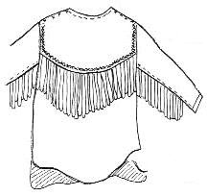

There is also a general lack of beadwork, quill work, or fancy embroidery on coats depicted by Miller & others. Remember, these were working clothes, worn by working men. As Norman (1996) says, …the images of trappers show men dressed and equipped with function, durability and practicality in mind, well suited to their environment and profession.

There are a number of extant examples of coats with elaborate bead, quill or embroidery work, but these are generally considered as prestige items, special dress items, or were brought back from the “mountains” as “souvenirs.” Because they were “fancy,” is probably the reason that someone saved them or put them in a museum. There is no evidence that any of these coats were worn in the field or by the working men of the fur trade. Miller shows no pockets or cuffs on any of his leather shirts/coats. Lengths are from mid-thigh to knee, not to mid-calf. Fringe may sometimes seem elaborate, but they are not excessively long, especially on sleeves, where just as many show no fringe. Long sleeve fringe is a real nuisance for a working man. The longest fringe shown is usually on the shoulder. No antler buttons are ever shown, on coats or any other garments. Most coats shown by Miller use ties to close & he shows no buttons.

.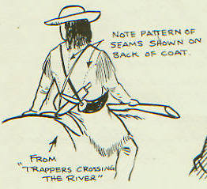
Here is an excellent sketch by Rex Allen Norman showing “Trapper Crossing the River” depicted in one of A.J. Miller’s 1837 field sketch (Norman, 1996). Norman & Miller have shown very well here the “key hole” or two piece back common to most coats from this time period.

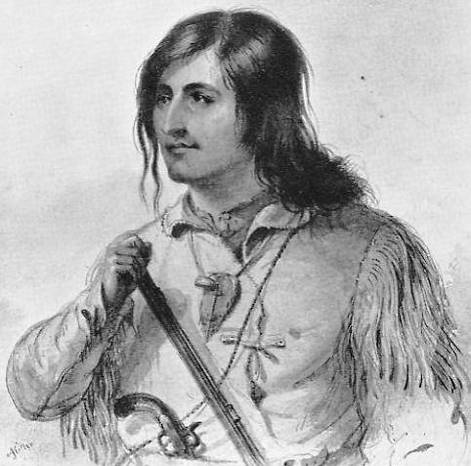

Here is Alfred Jacob Miller’s sketch of Antoine Clement (Ross, 1951). Notice his leather coat has fringe only on the shoulders. The sleeves are fitted with no fringes but they have a welt on the under seam. The coat is also held closed with leather ties.

Although it is a popular myth that fringe on leather coats or other garments was practical to help the garment dry faster, tests have shown that this is not true. Other than when you need an occasional short wang, fringe is not useful & it is primarily decorative.

Most leather coats depicted in period sketch & paintings seem to be well fitted & constructed, although there are some extant examples that are not so well fitted. Chronister & Landry (1995) tell us that, …leather hunting shirts…were available ready-made in St. Louis and Independence, and at the larger trading posts in the West. William Drummond Stewart describes his outfit upon departure from St. Louis as including a “leather shirt over my cotton one.” Since Stewart is wearing the leather shirt over a cotton one we would, by our definition at the beginning of this article, call this a leather coat or jacket. Fort Union had two leather hunting shirts in its inventory in 1831. The records of the American Fur company retail store in St. Louis contain occasional references to sales of leather or deerskin hunting shirts in the early 1830s. Fort Hall in the mid to late 1830s also indicated the sale of a number of leather hunting shirts. Today we could easily think of these as light leather pull-over jackets as most were worn over cloth shirts. These may have been called shirts because of the “cut,” being perhaps shorter, pull-over style, and constructed in the traditional shirt pattern. I say pull-over because shirts are all predominantly pull-over shirts until the early 1900s, so when they historically refer to a shirt it is assumed that it is a “pullover.”

We would recommend Rex Allen Norman’s 1837 Sketchbook of the Western Fur Trade, James Hanson & Kathryn Wilson’s Mountain Man’s Sketch Books, Vol. 1 & 2 for some ideas on styles of leather coats.

The clothing of the hunters themselves, is generally made of prepared skins, though most of them wear blanket "capotes," (overcoats,) … Some of them however, make coats of their buffalo robes, which are very warm and comfortable in cold weather, but become rigid and useless, if they are exposed to rains, or otherwise get wet. (Ferris, 1983).

…his personal dress is a flannel or cotton shirt (if he is fortunate enough to obtain one, if not Antelope skin answers the purpose of over and under shirt) a pair of leather breeches with Blanket or smoked Buffaloe skin, leggings, a coat made of Blanket or Buffaloe robe a hat or Cap of wool, Buffaloe or Otter skin his hose are pieces of Blanket lapped round his feet which are covered with a pair of Moccassins made of Dressed Deer Elk or Buffaloe skins (Osborne Russell, 1955).

Rex Allen Norman (2006) says that …There are several [leather] coats in collections, both public and private, that are definitively or believed to be of New Mexican origin. In general terms, they are semi-tailored and long length. The fit of many of the leather coats is simple, even crude in some cases. Short fringing is rather common, and added fringe section on sleeves and hems are as well. Some display very fine leather lace construction. This lacing should not be confused with the “kit buckskins” look, but rather closer to actual sewing in its fin workmanship. Sometimes lacing was added just for looks rather than holding the parts together.

Leather or “buckskin” garments were available and regularly purchased in St. Louis prior to departing to the west. Trappers moving through Taos and Santa Fe could also outfit themselves in leather garments. Fort Hall and other fur trade forts, employed both Euro-Americans and Indian women as tailors to fashion both buckskin and cloth garments. The Fort Hall ledgers indicate the regular sale of both leather and ready made leather garments. We sales of …elk-skin trowsers, …2 skins for making pants,… deer skin pants, …dressed elk skin for moccasins, …leather pants, …Indian leather pantaloons, and other entries for …leather hunting shirts. As Clay Landry (1999) says …there are numerous entries showing purchased of ready-made leather or buckskin garments and dressed elk and deerskins, which could habve been made into leather garments.

Chronister and Landry (1995) relate that in 1833 there is an Assiniboine man painted at Fort Union by Karl Bodmer. He is wearing a buffalo hide coat with the hair inside. Chronister and Landry go on to say that the coat does not have a hood & seems to be a very basic tailoring with a cape over the shoulders & could be similar to the coats referred to by Ferris.

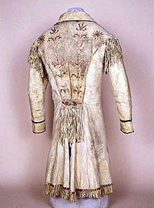

The Metis coat has not been discussed here in detail, but it is generally a leather copy of a frock coat. They characteristically have a very narrow bottom to the key hole at the back waist. The survival rate of Métis hide coats is extremely high. Some of the best examples are lodged in the Museum of Civilization in Gatineau, & there is an outstanding example in the Bata Shoe Museum in Toronto. There are also several in the Hudson's Bay Collection (Barry McPherson, 2006). Many of these are quit heavily decorated either with quills, beadwork, and/or embroidery. Again, the reason that so many of these highly decorated examples exist is probably because they were procured as souvenirs or for museums, & precisely because they were so fancy people saved them.

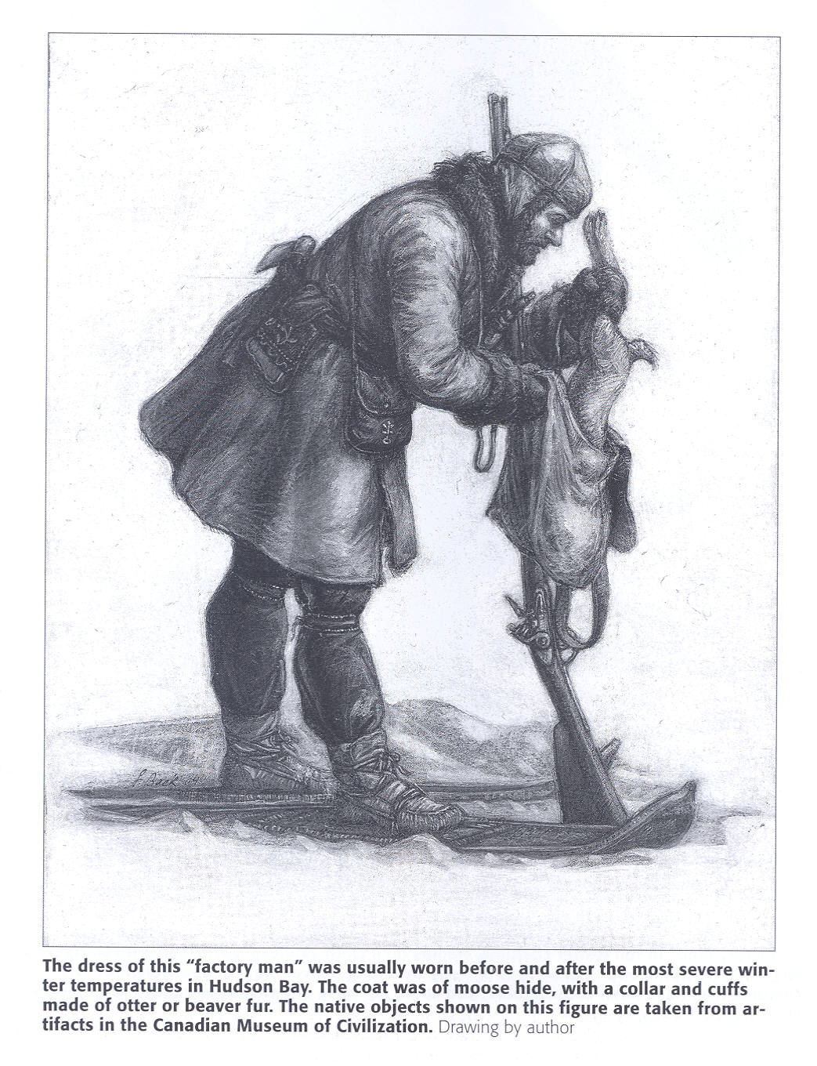

Here’s another type of leather coat (moose hide) depicted by Francis Back (2004). Note that the length is above the knees, that it is flared or
skirted at the bottom, & the sleeves are fitted & not tubes. It has fur collar & cuffs, & as the caption says they were made of otter or beaver fur. This seems to be cut in the style of early capotes. This figure was derived from the artifacts in the Canadian Museum of Civilization.

Overcoats, Surtouts, Watchcoats or Great Coats

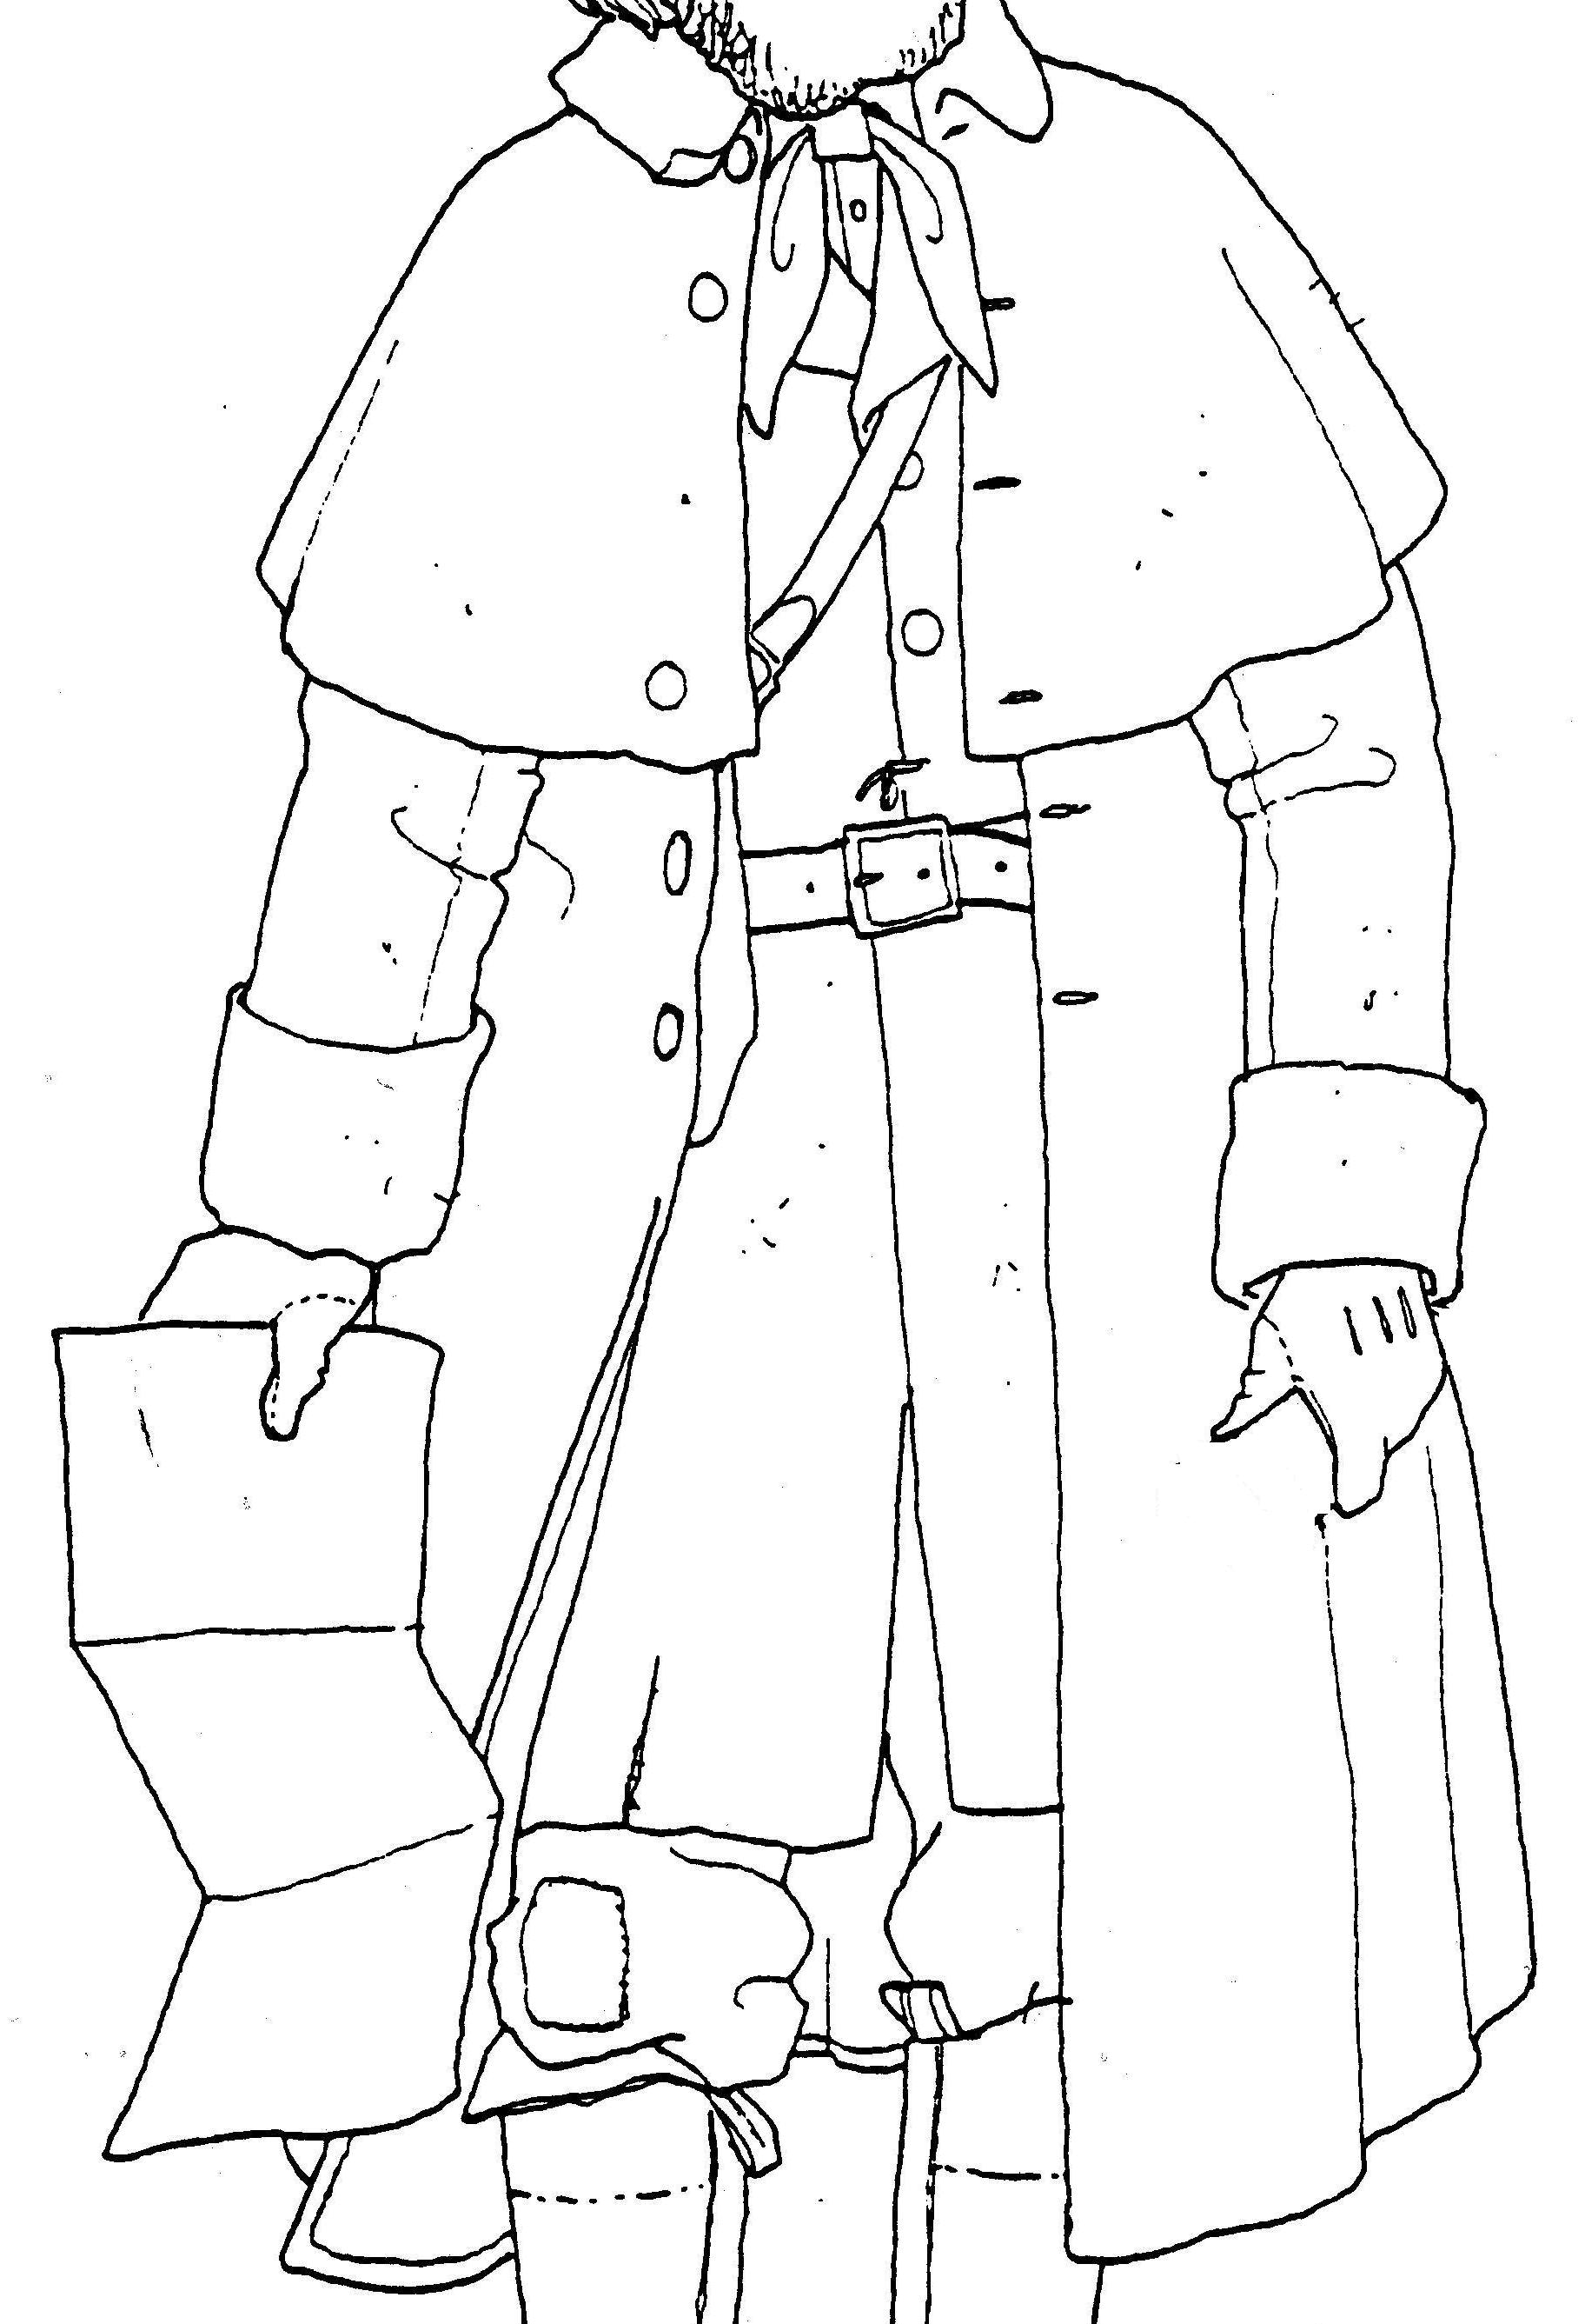
From D.W. Rickman, 1988. Sutter’s Fort Costume Manuel.
These coats were normally of heavier material, usually some type of heavy wool or duffle, & longer. Similar coats of canvas, oil skin or Russia sheeting were also used for wet weather by seaman & others. Many had a cape or capes much like the military watch coats or surtouts of the day. The surtouts is an overcoat in the style of a frock coat & is what the military designated their more tailored & finer made officer’s and NCO’s overcoats in the early 1800s The caped styles of military coats persist with the military through the civil war & into the Indian Wars time period, but were also popular with those who had to be out in severe weather..

These coats are generally a little longer than the frock coat, are often at or below the knee, & are flared, pleated or skirted from the waist toward the bottom. This flared bottom allowed the wearer to walk more easily. They are not “tubes” in construction. They may or may not have pockets, & were often lined with lighter wool, flannel, cotton, or linen, with the more expensive ones lined in satin or silk. These coats could of course be called capotes too, popular with the French and/or Canadians.
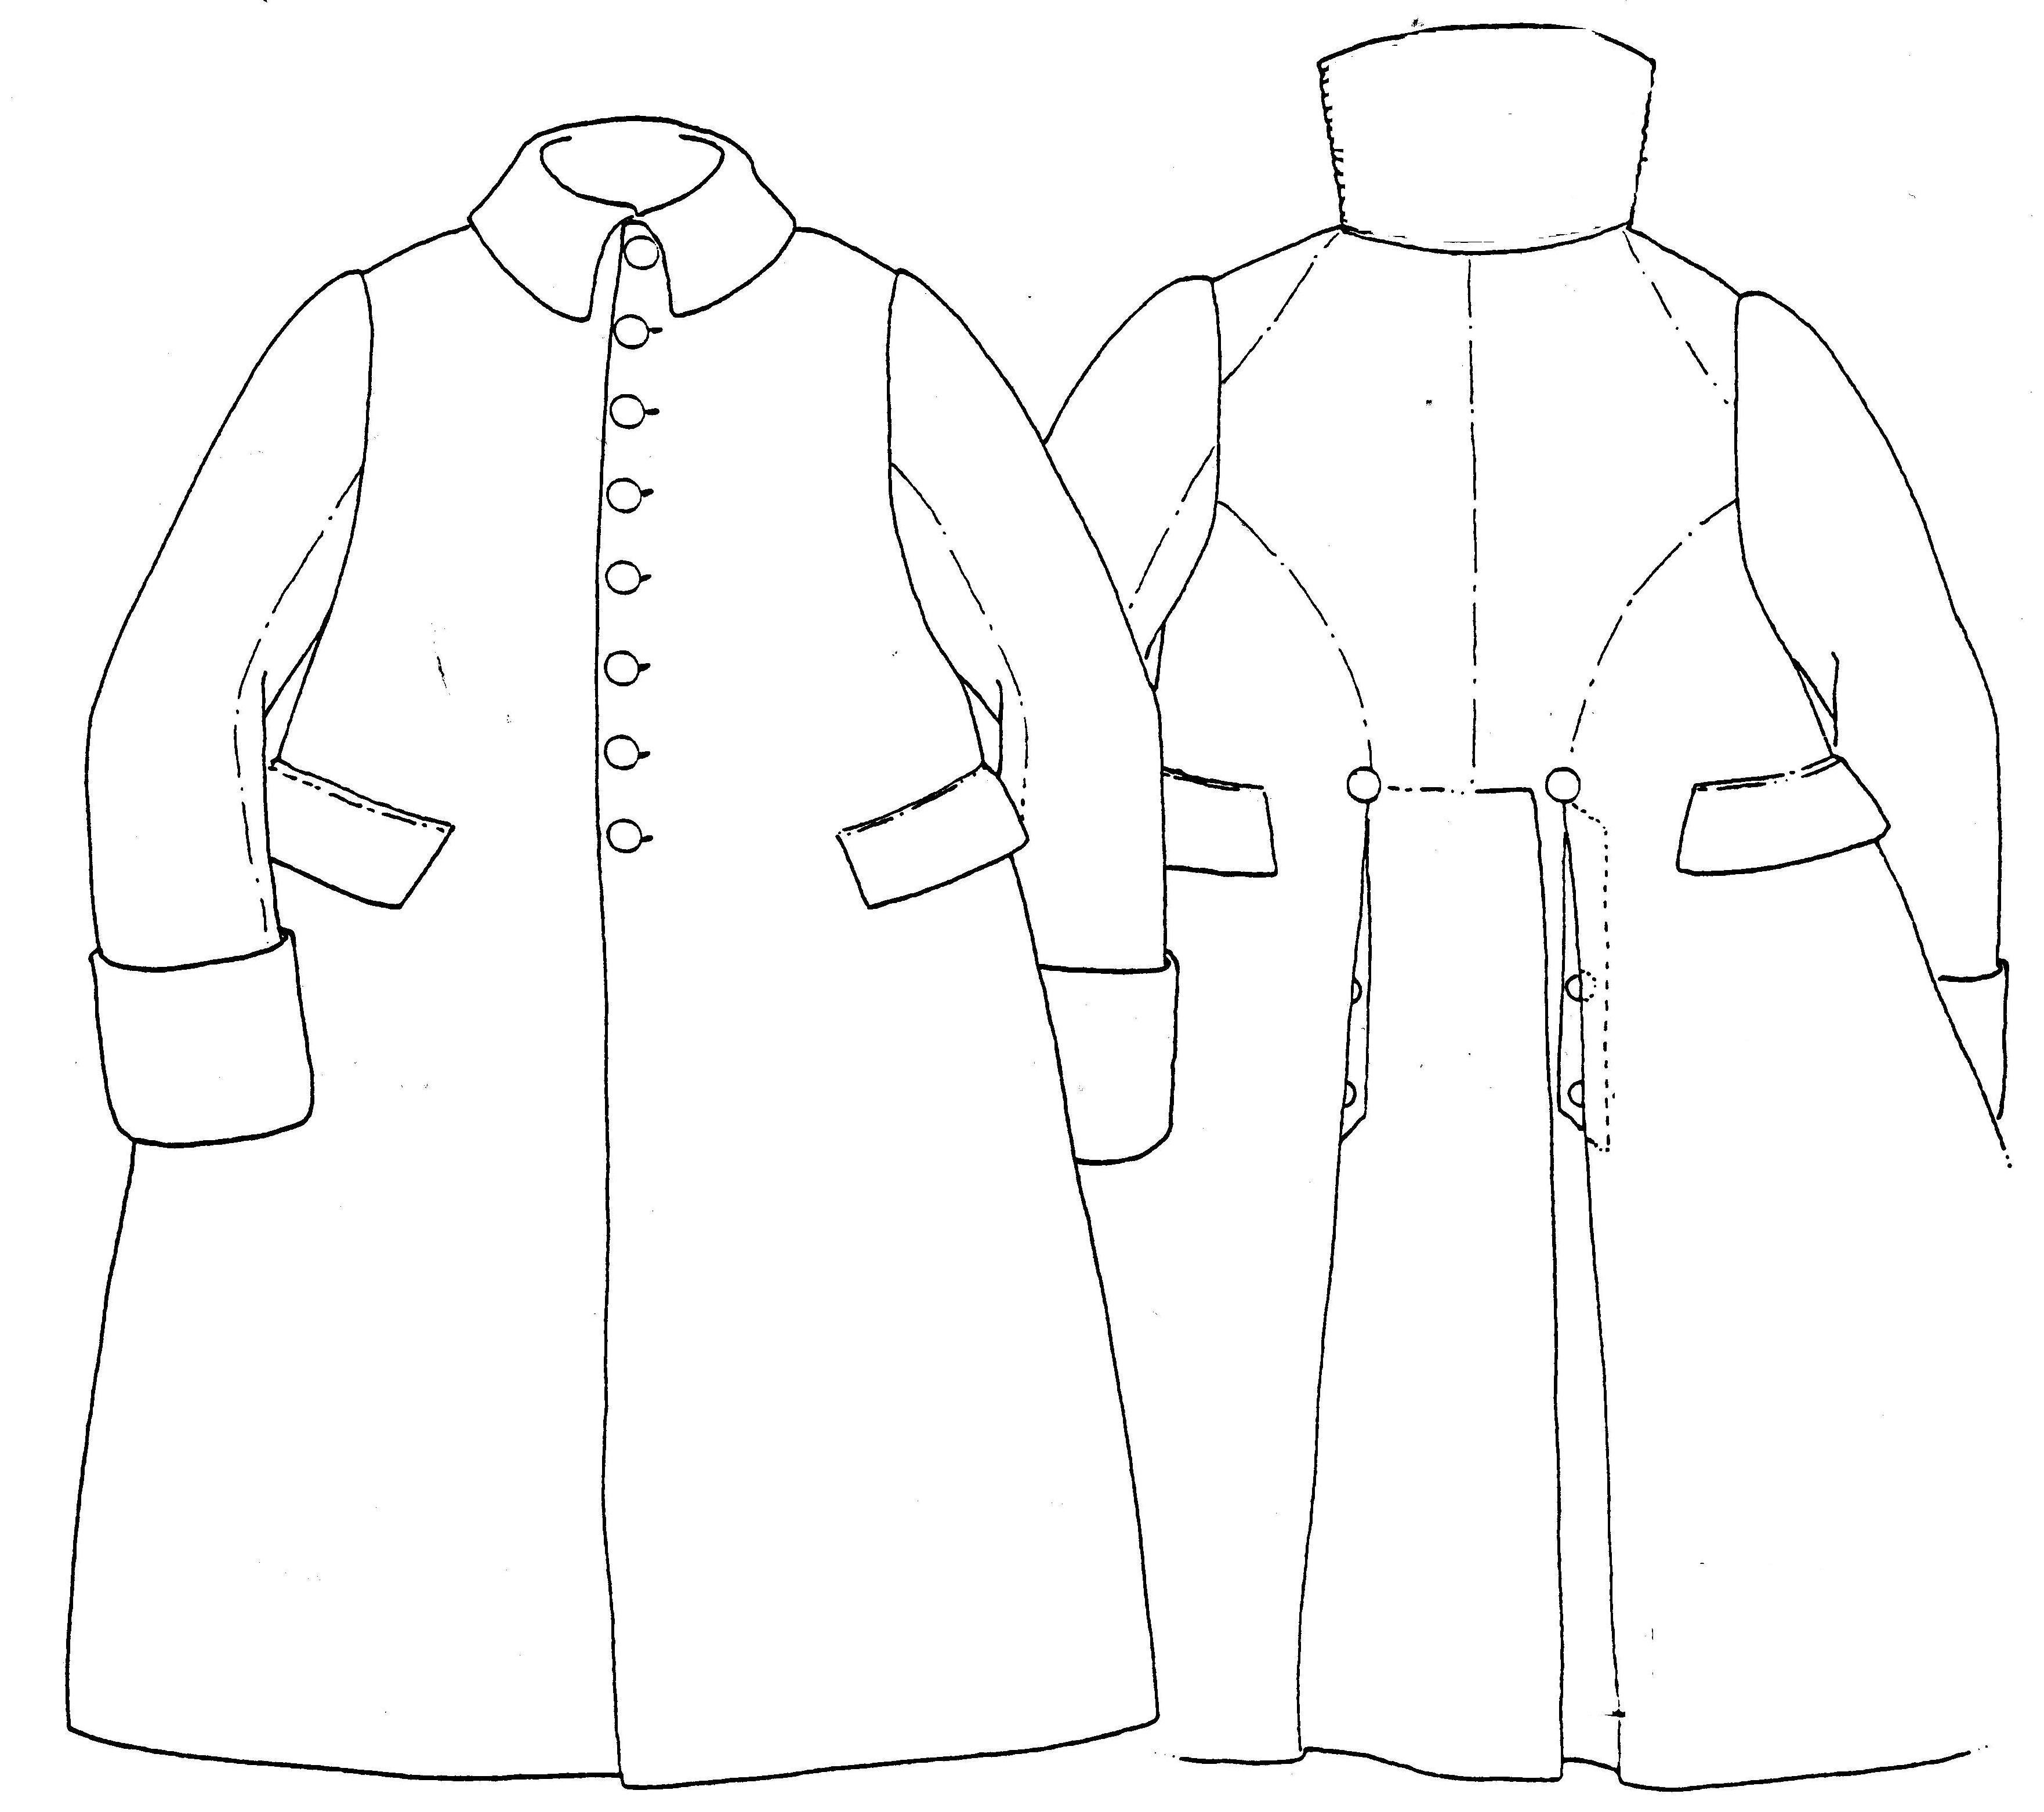
From D.W. Rickman, 1988.
Sutter’s Fort Costume Manuel.

Capotes
The capote most of us think of from today’s modern rendezvous is appreciably different than a capote almost 200 years ago. Among European fur traders, the cut of capotes seem to mirror the style lines that one would find in frock coats of the period. This holds true as well, for the leather coats worn by the Métis & Europeans working in the trade. Many more were made of a lighter more tightly woven wool, than the heavy blanket type capotes so often seen today. The reason that so many of the Canadian capotes look the same, may be because the HBCo. capotes were produced in Britain to a standard pattern.

…the common outfit for clerks when traveling was a gray-blue capote with silver-plated buttons, a broad worsted sash, silf-worked moccasins and navy blue cap with leather peak [clerk’s cap] (Newman, 1985).

Osborne Russell (1955) says a trapper’s dress is in part …a coat made of blanket. Ferris (1983), in his Life in the Rocky Mountains, says that …the clothing of the hunters themselves, is generally made of prepared skins, though most of them wear blanket “capotes,” (overcoats,)… Then William Drummond Stewart (1854) buys in St. Louis an …overcoat of white blanket with a hood…

The Canadians are a swarthy people, and low in stature; their dress consists of…when the weather is cold, a blanket coat, which they fasten around them with a worsted sash. They mostly wear a woolen cap, but in cold weather a fur one… (Anburey, 1969).

Capotes are probably one of the most typical styles of coats seen from Canada & …the voyageurs and fur trade companies spread the use of the capote to the four corners of the North American continent, and nobody should be surprised to find references to capotes coming from New Mexico or Hudson’s Bay (Back, 1991). Angela Gotfred (2006) says that her …research suggests that men's capotes should be knee-length and tied with a sash. Capotes were most often made from melton cloth or blankets, but leather capotes are also recorded.

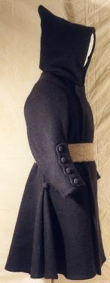
Replica Capote from Deerfield Museum

The capote style of coat goes back to a sailor’s or fisherman’s coat of the 1600s. It was the common coat for Canadians. Early French capotes tried to imitate the justaucorps, the fashionable coat of the day. Early capotes had mariner's cuffs with multiple buttons (shown at left) up the sleeve, some sleeves were plain & others had long "boot cuffs" like those on justaucorps, & most seem to be navy blue. Among Europeans & Anglo-Americans, the cut of capotes seem to mirror very closely the common style lines that one would find in frock coats of the period. This holds true as well, for the leather coats worn by the Métis & “half-breeds. Capotes are easy to make & several patterns are available. Most late 1700s or early 1800s frock coat patterns available today, such as the one from J.P. Ryan, could be easily modified into a good capote for our period.

The capote is often described as having one button at the neck. It is usually closed with a sash or belt. For a common working man’s capote the buttons were often wooden molds covered with fabric. Buttons may be fabric, horn, or plain style pewter or brass, about 1” in diameter & slightly domed.

If you went by the capotes seen at modern rendezvous the box style would seem to be the only style & blankets would seem to be the only material. However, when you examine the records, inventories & limited extant examples only a very limited number of capotes were made from blankets & the box style seems to be an Indian style of the late 1800s. Capotes are sometimes referred to as blanket coats, but more commonly are made from serge, duffle, or a blanketing wool rather than an actual blanket, although some were obviously sometimes made from blankets. Blankets in the late 18th & early 19th century were both expensive, & more useful as a blanket than as a garment. Besides being more costly blankets do not, in our experience, cut the wind or shed moisture as well as some of the more tightly woven wools. Even with this other more tightly woven woolens, capotes could be cheaper than the blankets that had to be cut up. It would be rare that a capote could be made from a single 3 point blanket, the larger size of blankets usually sold during the fur trade. Using a single 3 point blanket would be especially so for us much larger 21st century men. However the advantage in making your own capote from blankets is that there will be enough scraps left, especially if you cut two blankets, to make moccasin liners, mittens, etc. Sashes or belts are used to secure the capotes closed & there is no documentation for sashes or strips cut from blanket material as we often see today.

In 1837, pairs of white, scarlet & green 3 point blankets were selling for $8 each & 3 point blue blankets for $7. In the same inventory blue blanket capotes were $8 & green blanket capotes were $7 & others for as little as $6.75. It would appear from this, that it may have been cheaper to buy a capote than to cut up blankets. (Rocky Mountain Outfit, 1837).

However, the ledgers of Fort Hall show several …green Capoe [$]20 for Indian trade, then a Blue Capeau to Wm. Waller for $18, and another entry for Samuel Knott who gets 1 Capoe for $11 and a blanket for $3.50. So perhaps Knott’s Capoe was made from these cheaper blankets. Other Fort Hall ledger entries show “wrapper” blankets, a cheaper grade of blankets used to wrap goods in shipment, going regularly for $6.00. At this same time period an entry for blue wool cloth sold for $6/yard (don’t know the kind or quality here, but from the cost it must be very fine stuff) and red wool for just $1.50/yard. Definitely a real difference in the quality and kind of wool between these two. We don’t know if this $1.50/ yard wool would have been of a weight sufficient for a coat, but it would perhaps have been of a weight sufficient for a coat lining. There would also be many times when a guy only had a blanket(s) & no wool material to cut into a coat, but wool fabric is as common as are blankets in the trade records.

In 1834, the naturalists John Townsend & Thomas Nuttall arrive in St. Louis to accompany Captain Wyeth west to the Columbia River (Townsend, 1839). Wyeth meets them & immediately takes them to town to get them outfitted. In Townsend’s diary/field notes he says that Wyeth selected for each of them …an enormous over-coat made of green flannel. However in the published book of his journey Townsend says he [Wyeth] had them purchase …enormous overcoats, made of green blankets… So are they flannel or blankets? It may be that they were made of wool flannel commonly used for blankets or a wool blanketing cloth. Being that they were probably tailor made in St. Louis or imported, it is doubtful that they were cutting up blankets, as it would be much more expensive to do so. It may be that the terms “blanket coat” or “blanket capote” was the common term for these coats, whether they were made from blankets or not, as many were made from blanket weight wool, but not actual blankets.
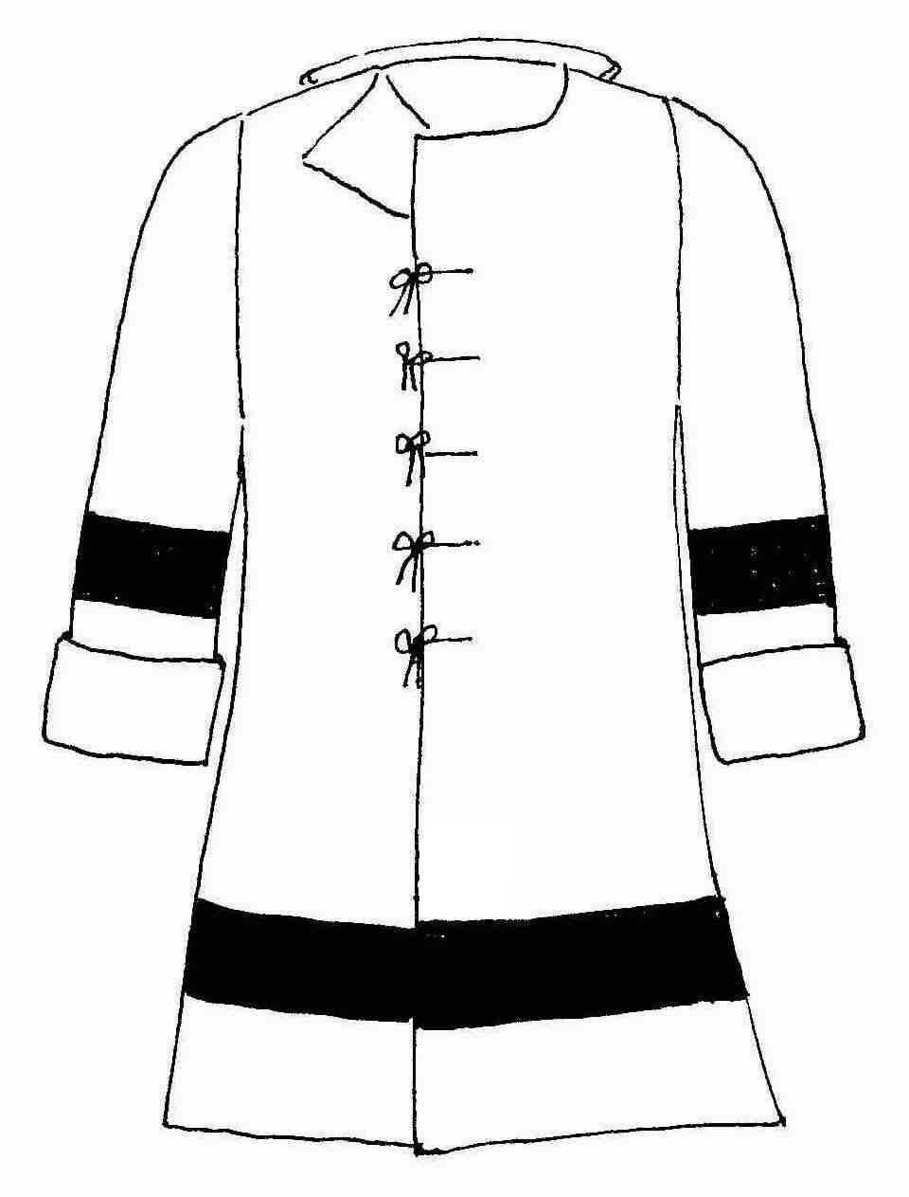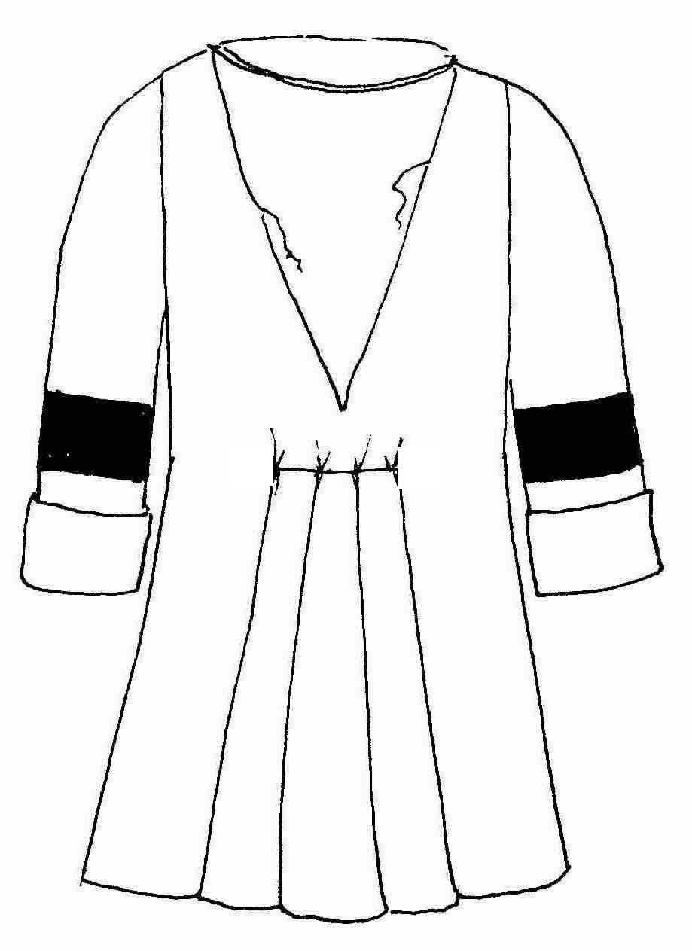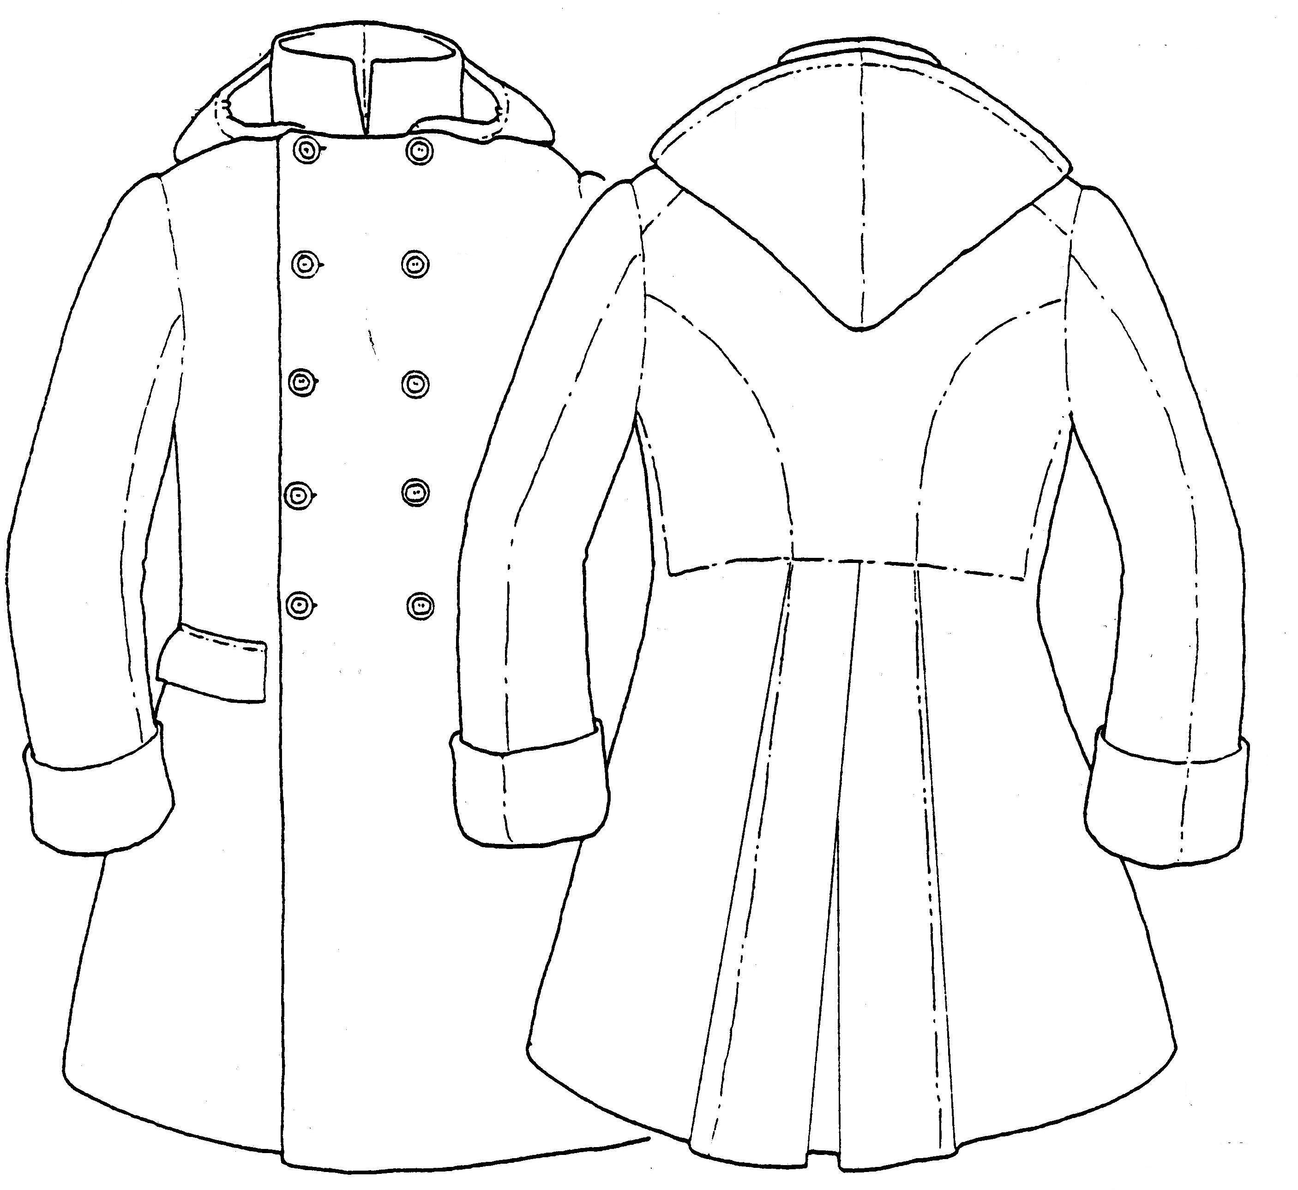
Susan Hickman, 2003 From D.W. Rickman, 1988.
Sutter’s Fort Costume Manuel.

A blanket, as we all know, absorbs water, stays warm when wet & is a good insulator but is not a particularly effective as a wind breaker. However, if it is covered with or lined with a tighter & less lofty fabric it is much more effective in wind. As the record seems to indicate, most capotes were not cut from blankets & most also seem to be made of from lighter woolens than those found in blankets. Many of capotes in the inventories were cut from Melton, molton, stroud, baize and other woolen fabrics which had the ability to cut the wind and shed moisture. Duffle cloth would be a good option for a capote, or a lined melton cloth. Duffle is tighter than blanketing, [ also less bulky], and is certainly less expensive than cutting up new blankets. (McPherson, 2003). Coat or capote linings were often of linen, gabardine, satinette, wool, other tight weave materials or even corduroy. A capote in the Pitt Rivers Collection in Oxford, England, collected in 1846 is …made of heavy curly or wavy nap indigo blue wool…Coat is fully lined with Scotish wool tartan (Hanson & Wilson, 1976). There is also evidence of capotes which have contrasting cuffs & “wings.”

Most capotes in sketches, paintings & the extant capotes seem to be well tailored garments, with articulated sleeves & key-hole or two-piece backs, & not simple box tube bodies and sleeves. HBCo. was importing ready-made capotes from Britain & several of the trade forts also had tailors or Indian women sewing garments for them, & of course Indian women were adept at copying the pattern of a worn out coat into a new wool or leather coat of Euro-American style.

Based on all of the original evidence, the fur-trade era capotes worn by both whites & Indians, had neither the shoulder-fringes, decorative cuffs, hood-tassels, embroidery, antler buttons, beadwork, nor belts made of blanketing, found on so many of the capotes worn by modern buckskinners. Rindisbacher, however, does show a hood-tassel, as does Kurz, both on Indian capotes, but Alfred Jacob Miller’s paintings of mountain men do not. We’ll probably never know for sure as no actual working capotes from this era survive (Rickman, 1988).

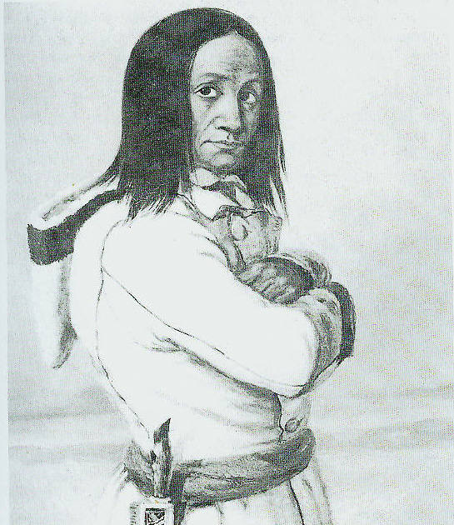

Chief Red Jacket by Cornelius Krieghoff (Harper, 1999). Note the welted seams, the “key-hole or two-piece” back and the articulated sleeves. Articulated sleeves are two part “fitted” sleeves that are shaped like the bent arm vs. the “tube” style sleeve seen on modern capotes. The capote is also double breasted & you can also see the beginnings of a flare for the skirt below the sash.

The paintings of George Herriot & John Lambert, along with the journal
entries of Peter Fidler, strongly suggest a snug fitting, relatively short, single breasted garment with a modest amount of styling/fitting (McPherson, 2003).

30 Blue Blanket Capots $8.00 [ea] $240.00
41 Green Blanket Capots $7.00 [ea] $287.00
10 Blanket Capots $6.75 [ea] $67.500
(Rocky Mountain Outfit 1837).

1 cappot $12.00 Robert "Doc" Newell 1829 through 1842 in his Memorandum of Robert Newell's Travels in the Teritory of Missourie.

A List of the various articles, taken from the invoices furnished by the Traders at the Superintendency St. Louis, …1831 shows 60 blue and grey cloth capots, most of which were destined for the Indian trade. (Russell, 1985).

Here in Miller’s painting, The Trapper’s Bride, the victim (trapper/groom) is wearing a soft blue or green wool coat with a hood. Charles Hanson (1975) says that this is probably one of the commercial capotes handled by many trading companies & especially popular with “French Creoles”. This also appears to be made from a lighter weight material. It is interesting to note that there are at least three versions of 'Trappers Bride' by Miller showing somewhat different details in each of them.
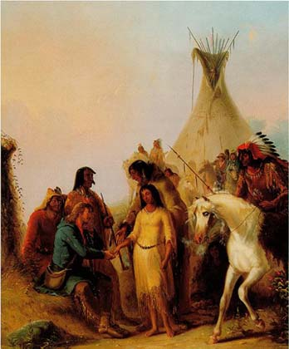

Today, if you purchase blankets from one of the many suppliers, it could run up to several hundred dollars, since good blankets are generally at least $100-$250. This of course depends on the type & quality of the blanket used. Our advice, is to research other sources of wool, but do sew your own capote, they’re easy. It may be that in today’s market the blanket is cheaper than the other sources of wool. However, the articulated sleeves can drive you crazy, so you need to pay attention to the pattern & instructions. Stay away from the 1870s style Indian “Tube” Capote so common at modern rendezvous.

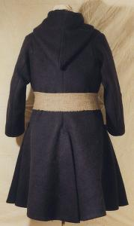
Replica from the
Deerfield Museum

Make the shorter, above the knee style capote with a skirted or flared bottom, which is the style for our period. Using a shortened military style watch coat pattern without capes, would also give you one correct style for a capote. Capotes should probably be made from duffel or melton, blanketing or if you have to, from an appropriate white, blue, black or green blanket. The coat made from a point blanket is extremely popular today – much more so than it was in frontier times (Hansen, 1988).

Cpt. M. Lewis, June 5th 1805 …This morning was cloudy and so could that I was obliged to have recourse to a blanket coat in order to keep myself comfortable altho’ walking (Moulton, 1995). Whether this was a civilian style blanket coat (capote) or the enlisted military blanket coat, the enlisted watch coat or even the officer’s surtouts is unclear. Either way Meriwether Lewis had one on June 5th 1805.
Military coats of our time period would also be appropriate in the fur trade either being worn by ex-soldiers, deserters or those procured through surplus items.

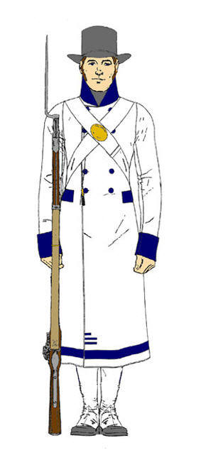 Enlisted Blanket Coat
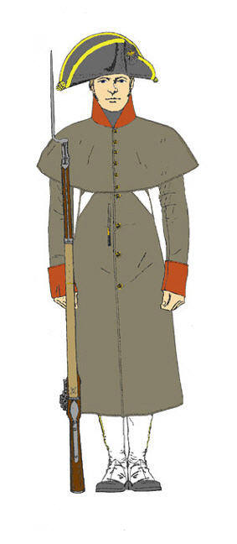
Enlisted Watch Coat
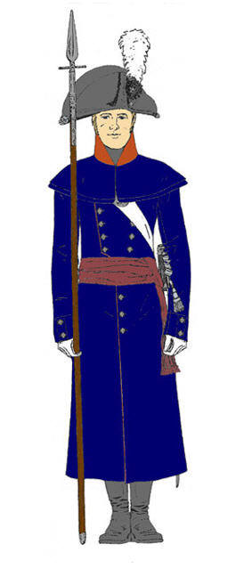
Officer’s Surtout

The term “capote” was generally used during the fur trade period & beyond. It is French & is commonly defined as “a long cloak, usually with a hood” (Webster, 1998 and Mueller, 1987). Capotes for the fur trade time period, were almost never below the knees, did not usually have a long “tube” or “box” body & tube sleeves, & DID NOT have the multi colored bands of red, green, yellow, and/or black (Candy-Stripes) like you see in a lot of non-period artwork or on many modern capotes. This style blanket/capote came later in the 1800s. Wool blankets that have natural color (white) with a single black or navy band were the most common blanket. Many artists of the time show capotes, usually Indian capotes obviously made from blankets, which are white with the a darker colored band. On the other hand, the most common color of tailored Canadian capote seems to be navy blue, often trimmed in red followed by white, trimmed in blue or red. Navy wool was also by far the most common color of wool material traded & sold. Capotes could have been made from blanketing wool or common blankets & again these “blanket” capotes most commonly are white with navy, red or light blue stripe. Even rarer would be colored blankets such as green with black stripe, red with black stripe, light blue with black stripe, dark gray with or without black stripe, or natural color with black stripe. Colored wool blankets were generally more expensive than white blankets and probably accounts for the predominance of white blankets. Most of the capotes shown in Krieghoff or Rindisbacher seem to be white or off white with either the navy or red stripe.

We see a great number of capotes in the Krieghoff paintings & many of those are shown in this paper. …In fact his winter scenes depict an enormous number of capotes - to the point where the observer begins to think that the same garment is being used over and over again. However, his choice of style and color lines up with the fabric in the market place at that time. Many of his capotes have been cut from blankets, but keep in mind that Krieghoff was painting for a commercial market in Quebec (McPherson, B. 2006).

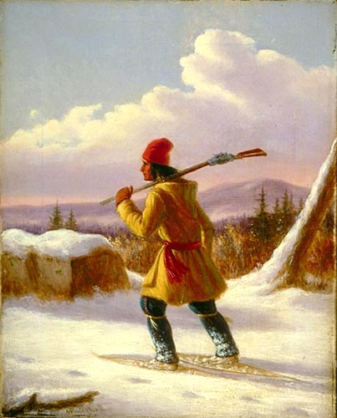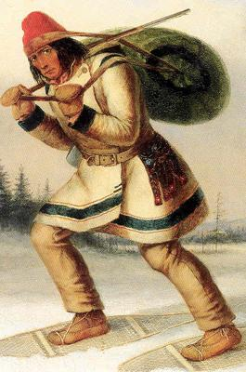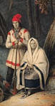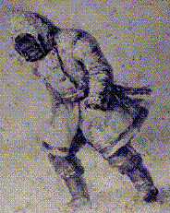

Several paintings by Cornelius Kreighoff shown here show the short skirted capotes. The capote in the second picture is clearly made from a point blanket as the points are visible at the opening. These are all Canadian Indians & Metis.
I don't believe that I have come across many, or perhaps even any references to red blankets during the life span of the NWCo. I'm sure they did exist in a civilian context, but the cost of dyeing blanketing with either cochineal or madder would result in a fairly expensive blanket. However, the vast majority of blankets and capotes of that time would be white (McPherson, 2003).

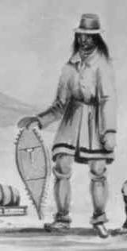
1839 Sketch - Chaplin.
Capotes, sometimes called duffle coats, were tailor made of wool blanketing fabric, duffle, or occasionally from blankets (McPherson, 2003). Generally, they were shorter, above the knee and flared from the waist down, which is different than the familiar capote so common today. Modern rendezvous capotes are long (below the knee), straight hanging tube bodies, wide sleeves, fringed and/or beaded and/or made with “candy striped” HBC blankets, most of which are copies of Indian style capotes of the 1870s. The tendency today is to make capotes from heavy wool blankets. However, most older capotes seem to be made of lighter weight wool, which does hang and fit better than the heavy wool (McPherson 2006, Koster 2006).

At this time the only source I know of for good historic quality French capotes is Flying Canoe Traders or Bushwoman’s, although a number of period seamstresses & tailors will probably make these up for you if you ask. Most are making the late 1800s capotes because they are quicker and cheaper to make and that is what the customers unknowingly want. The Flying Canoe Traders’ French capotes is made of high quality boiled Canadian wool, & they are a wrap around coat with one button at the top, closes with a sash or belt & has a hood. They are from an earlier period than ours, but it is mostly due to the wide tall cuffs, which can be modified or removed for our period. According to Flying Canoe …the coats have elegant lines that will narrow down to the waist and grace fully spread out at the lower part. Besides being historically correct, the fit & flared style is a lot more practical for every days use, especially walking or riding a horse.

…Fringe, beadwork, yarn top stitching, matching sashes and other decorative embellishments are totally absent [from Capotes] and manufacturer’s labels were not placed on blankets until well after the Civil War… (Hanson, 1988). In fact most of these are modern rendezvous innovations.

Many, but not all capotes had hoods, & some later styles had stand-up collars with or without the hood. If you are building a capote, whether or not you want the hood is your option, although most have them. Capotes could have a single button, a single row of buttons, a double row of buttons, a tie or a system of ties. Early French Canadian & Indian capotes are commonly shown hooded with only one button on the upper corner or were merely kept closed at the neck with a tie or a gun screw. The Book of Buckskinning IV has instructions on how to make six different styles of capotes & shows four different blanket stitches. Unfortunately these patterns and even some the stitches are not historically correct, as they are all the late 1800s style Indian “box” capotes. These patterns would have to be modified to incorporate the historical styles & patterns. The Mountain Man’s Sketchbook, Volumes 1 & 2, show several styles of capotes from which a pattern can be made. Many late 1700s or early 1800s frock coat patterns, such as from J.P. Ryan, could also be easily modified to capotes. I can’t emphasis this enough, to be very selective in using any capote pattern, remembering that most capotes were usually tailored, narrowing at the waist, flaring toward the bottom like a skirt, stopping above the knee, & usually with articulated sleeves narrowing at the cuff , and not tube sleeves. So don’t be making the late 1800s Indian or modern rendezvous capote.
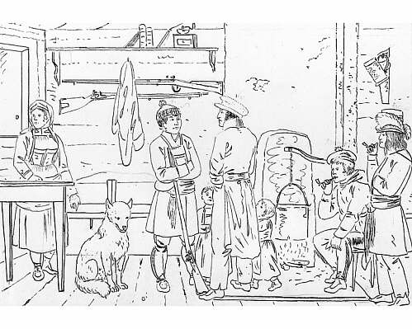
Here is a Rindisbacher sketch from the Red River Settlements of the 1820s. Note the frock coats & capote. The guy in the middles with his back facing out is wearing a tailed coat, also popular during this time period. Additionally we can see a variety of hats, i.e. a toque, a top hat, a clerk’s cap & a balamoral. There also appear to be cloth pants, leggings, leather pants, & all seem to be wearing pucker-toe moccasins & sashes.

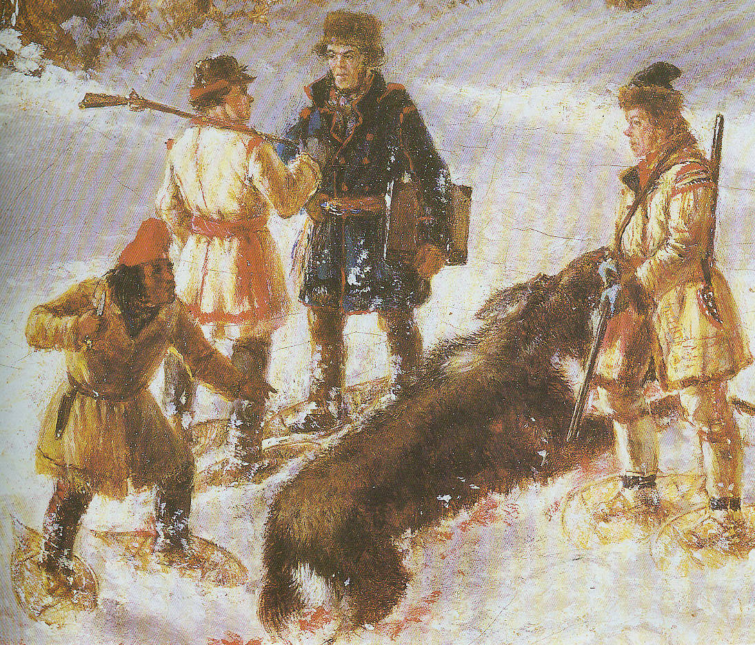
Here’s a painting by Krieghoff in a book of the same name by J. Russell Harper (Harper, 1999). This painting is titled the Death of the Moose. It is undated & may be from the 1840s or early 1850s. Note the variety of capotes worn by these hunters. The capote on the far right appears to be fur lined or hair on hide with the fur on the inside. A variety of winter caps here too. The guy in the navy capote, with the ledger, must be an early game warden checking for licenses.

Matchcoats
George Washington wrote of traveling in December of 1753: …I took my necessary Papers; pulled off my Cloaths; and tied myself up in a Match Coat. Then with Gun in Hand and Pack at my Back, in which were my Papers and Provisions, I set out with Mr. Gist, fitted in the same Manner, on Wednesday the 26th. (Washington, 1925).

Matchcoats were more common in the 1700s & very early 1800s. It was very common with eastern Indians & the “Long Hunters”. The use of matchcoats probably continued, especially with these eastern Indians, as they moved west & joined the trapping brigades. Here’s part of a letter from the Mquis, De Lafayette M.G. to his Excellency George Washington in 1777, concerning the uniforms, equipment & health of the men: Item the 5th. …The blanckets must have one or two buttons to surround the breast and be a kind of great coat.

These matchcoats or “buttoned” blankets don’t seem to be associated with Euro-Americans traveling to or in the Rocky Mountains, but they were undoubtedly familiar with them & probably utilized blankets as matchcoats from time to time. It would be easy to speculate that they’d use matchcoats when they had lost their coats, or as an extra layer when standing guard, for other sedentary activities, and/or as an extra layer in ver;y cold weather, The term “matchcoat is derived from an Algonquian word meaning a cloak or a petticoat (Potter, 1997).

Matchcoats are smaller blankets that can be worn as an outer protective layer or used as a blanket. As previously stated, they were a common Indian & half-breed item but may have been worn occasionally by Euro-Americans. The matchcoat is really a very practical & useful piece of clothing that was very common in Colonial America thru the Revolutionary War. Matchcoats were a common item in the American Revolution & especially in the “hay-day” of the Long Hunters in the Ohio, Illinois & Kentucky frontier. The matchcoat doubles as a coat & a blanket. The match coat would be most familiar with young men from the frontier Ohio & Mississippi River settlements, the mixed bloods (Metis) & even the engages (boatmen). The wearing of the matchcoat is hard to explain, but easily done. It is easiest to make a match coat from a square rather than a rectangular blanket. The only other items needed are, a blanket pin or sharp stick & a belt, sash, or a leather strap. Indian matchcoats were commonly decorated with metal lace (tinsel), ribbon, or worsted wool binding tape & many had “flap’s” or lapels & collars added (Potter, 1997).

...over my great coat I wore a blanket, pinned under the chin in the Indian fashion, and confined to the waist by a leather belt; to which was suspended a large hunting or scalping knife. Fifteen years ago, this was a common dress in Kentucky, as it is now on the frontiers of Indiana and in the Illinois Territory (Elias Pym Fordham; Fordham's Personal Narrative, 1817-1818…).

Wilde Weavery & Trade Co., http://wildeweavery.com, carry matchcoats & show the technique for wearing on their web site. Mark Baker’s video, Pioneering - The Long Hunter Series Volume Three, also shows a very good demonstration for wearing the matchcoat.

Ponchos or Sarapes

There are several sources for the old style of Spanish, Mexican, or what are sometimes called Rio Grand wool blankets. Some of these are made with the head hole to wear as a poncho or they can be easily modified. The hand woven wool blankets from Wilde Weavery are also easily modified into a poncho.

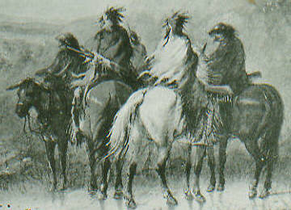
Here is a portion of the Miller sketch Storm: waiting for the caravan. According to Miller …it is raining cats and dogs…the main body [of men] are enveloped in ponchos;--we have found these coverings the most effectual of all in such unpropitious seasons,--they are simply made from a Mackinaw blanket, a straight incision is made in the centre to the length of about 14 inches, through this you thrust your head and behold your poncho falling as gracefully as a roman Toga all around you (Ross, 1951).

In Josiah Gregg’s 1844 Commerce of the Prairies (written of his experiences starting in 1831) describes the styles of dress in New Mexico …The sarape saltero (a fancy blanket) completes the picture. This peculiarly useful as well as ornamental garment is commonly carried dangling carelessly across the pommel of the saddle, except in bad weather, when it is drawn over the shoulders, after the manner of a Spanish cloak, or as is more frequently the case, the rider puts his head through a slit in the middle, and by letting it hang loosely from the neck, his whole person is thus effectually protected (Gregg, 1926). Sounds just like our poncho from Miller. This and other reference show that some if not many of the old New Mexican serapes may not have had a head slit. They were basically wearing blankets as matchcoats.

Literature Cited

Anburey, T. 1969. Travels Through the Interior Parts of America in a Series of Letters
by an Officer. Two Volumes. New York: New York Times & Arno Press

Back, F. 1991. The Canadian Capote (Capote), Museum of the Fur Trade Quarterly,
Vol. 27, No. 3

_____. 2004. Winter Traders’ Dress in Eighteenth-Century Hudson Bay. The
Museum of the Fur Quarterly, Vol. 40, No. 4, Winter 2004.

Chronister, A. and C.J. Landry. 1995. Clothing of the rocky Mountain Trapper,
1820-1840. The Book of Buckskinning VII. Scurlock Publ. Co. Texarkana, TX, 2-41.

Diana Invoice. 1835. Invoice of merchandise shipped on board S.B. Diana, C.M.
Halstead Master bound for the upper Missouri River & consigned for account & risk of upper Missouri outfit 1835 under mark in the margin. http://www.xmission.com/~drudy/mtman/bizrecs.html

Ferris, W.A. 1983. Life in the Rocky Mountains; A Diary of Wanderings on the
Sources of the “rivers Missouri, Columbia, and Colorado 1830-1835. The Old West Publishing Co. Denver, CO.

Gotfred, A. 2006. Capotes, with some Side Lights on Chiefs' Coats & Blankets, 1774-
1821. Northwest Journal, http://www.northwestjournal.ca/XIII3.htm).

Gregg, J. 1926. Commerce of the Prairies, U. Nebraska Press.

Hanson, C.E. 1975. The Mountain Man’s Outfit. Museum of the Fur Trade
Quarterly, Vol. 11, No. 3.

_____. 1983. Some Additional Notes on Trade Blankets. The Museum of the Fur
Trade Quarterly. Chadron, NE. Vol. 24, No. 4, pp. 5-11.

_____. 1988. Some Additional Notes on Trade Blankets. The Museum of the Fur
Trade Quarterly. Chadron, NE. Vol. 24, No. 4, pp. 5-11

____. 1990. The Traders’ Dress. Museum of the Fur Trade Quarterly, Vol. 25,
No. 1.

Hanson, J.A. & K.J. Wilson. 1976. The Mountain Man’s Sketch Book, Vol. One. The
Fur Press. Chadron, NE.

Harper, J.R. 1999. Krieghoff. Prospero Books. Etobicoke, Ontario, Canada.

Hunt, D.C. Hunt & M. Gallagher. 1984. Karl Bodmer’s America. Joslyn Art
Museum. Omaha NE.

Koster, K. 2006. Personal Communication. Grand Portage NHS, MN.

Landry, C.J. 1999. The History & Trade Ledgers of Fort Hall, 1834-1837. The Book
of Buckskinning VIII. Scurlock Publ. Co. Texarkana, TX.

Larpentuer, C. 1898. Forty Years a Trader on the Upper Missouri. University of
Nebraska Press, Lincoln

McPherson, B. 2003, Personal Communications. Winnipeg, Manitoba. Canada

_____. 2006. Personal Communication. Winnipeg, Manitoba. Canada

Missouri Company. 1809. Invoice of Sundry Merchandise sold & delivered to the
Missouri Company by Fr^{s} Regnier at St. Louis the 3^{d} May, 1809. http://www.xmission.com/~drudy/mtman/bizrecs.html.

Moulton, G.E. 1995. The Journal of the Lewis & Clark Expedition. University of
Nebraska Press. Lincoln, NE.

Mueller, G. 1987. Blankets in Early America. Book of Buckskinning IV. Rebel
Publishing Co., Inc. Texarkana, TX

National Park Service. 1995. The Things of Life. Fort Union Trading Post National
Historic Site. Buford, ND: in Chronister and Landry, 1995.

Newman, P.C. 1985. Company of Adventurers. Viking Penguin Inc. New York, NY.

Norman, R.A. 1996. The 1837 Sketchbook of the Western Fur Trade. Scurlock
Publishing Co. Texarkana, TX.

_____. 2006. The Trappers’ Southwest: Part Two. Muzzleloader Magazine
September/October 2006.

Payne, M. 1989. The Most Respectable Place in the Territory. Ottawa, Canada).

Potter, G.D. 1997. The Matchcoat. The Museum of the Fur Trade Quarterly.
Chadron, NE. Vol. 33, No. 4.

Rickman, D.W. 1988. Costume Manuel, A guide to the Clothing Worn in
California and the Far West, CA 1845. Sutter’s Fort State Historic Park. Sacramento, CA.

Rocky Mountain Outfit. 1837. Invoice of Sundry Merchandise furnished Rocky
Mountain Outfit 1837 under charge of Fontenelle, Fitzpatrick & Co. http://www.xmission.com/~drudy/mtman/bizrecs.html

Ross, M.C. 1951. The West of Alfred Jacob Miller (1837). University of Oklahoma
Press. Norman, OK.

Russell, O. 1955. Journal of a Trapper. MJF Books, NY.

Russell, T. (ed.) 1985. Messages from the President on the State of the Fur trade
1824-1832. Ye Galleon Press, 1985, Fairfield, WA.

Stewart, W.D. 1854. Edward Warren. 1986 ed. Mountain Press, Missoula, MT.

Townsend, J.K. 1839. Narrative of a Journey across the Rocky Mountains, to the
Columbia River, and a Visit to the Sandwich Islands, Chili, &c., with a Scientific Appendix. Oregon State University Press. Corvallis, OR.

Washington, G. 1925. George Washington, Diary. Riverside Press, Cambridge, MA.

Webster, N. 1998. Webster’s 1828 Dictionary. Copyright 1998, Christian
Technologies, Inc. Independence, MO.

